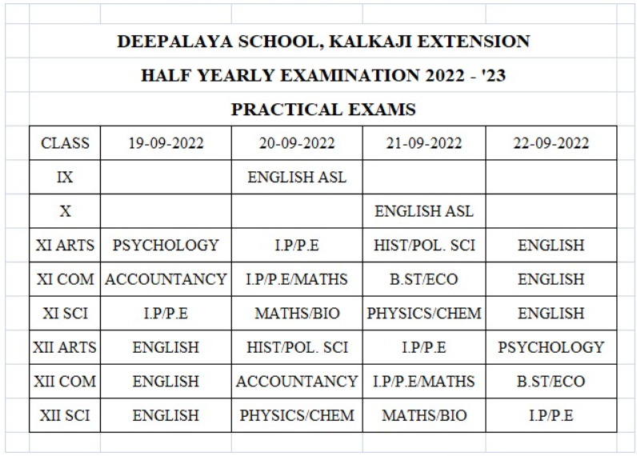

Dear Students please note during examination days (5/9/22 to 16/9/22)
# Reach school on time with proper uniform
# Don’t bring study materials 📚
# Bring clear pouch for writing materials and water bottle
# Have healthy breakfast
# Prepare well for your examination.
ALL THE BEST FOR YOUR EXAMINATION

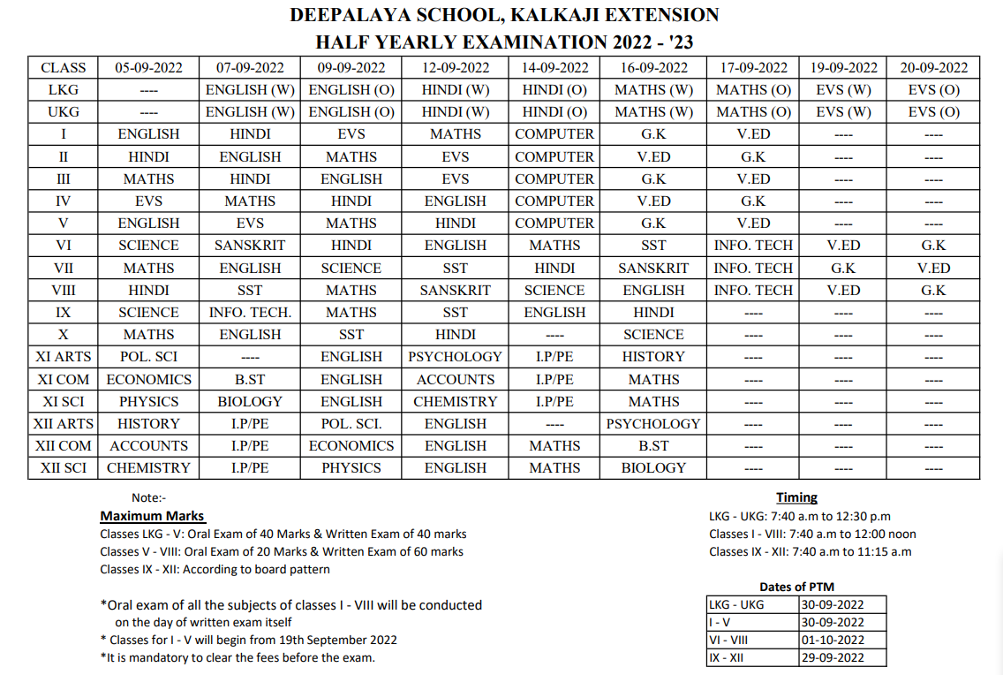
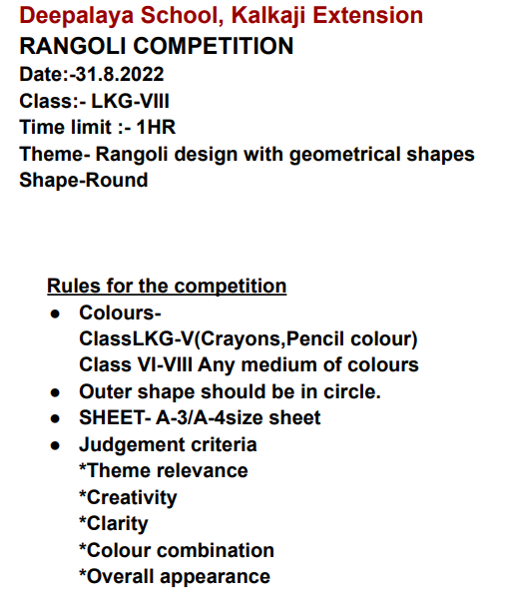
Exam -

Exam will be conducted in three parts.
Part-I
(Subjective/Written Exam)
Time - 8.30am to 9.30am
Write your Name, Class and Roll number on the top very clearly. Send your answersheets in PDF in Google classroom only maximum by 9.45 a.m. Keep them safely with you.
Part - II
(Objective Exam/Google form )
Time - 10.00am to 10.30am
Link will be disabled after 10.30am. Make sure you submit before that.
Part - III
Oral Exam
Time - 11am to 2pm
It will be conducted on Google Meet. Link and time slots will be sent. Please wait patiently for your turn. Don't disturb teachers by calling them again and again.

